Cassandra Diaz
English 10
Bigelow
By

Virgo At Heart

Dear reader,
Welcome to my multi genera. I never wanted to do something depressing as the actual piece, which is why I chose to do it on the character that I cosplay as, Kanaya Marayam. Cosplayting is one of the things that just seem to make me happy. It uses a lot of creativity and my artistic skills, but most of all it revolves around acting, which is something new for me. I have been cosplaying for less than a year. One of the biggest chalanges that I have found is how developed some characters are over others.
What is cosply? Cosplaying is when a person choses a character from tv, books, manga, or comic to use in rp. The essentially act out that character, as well as dress for the part.Cosplaying is about having fun with friends, making new ones, and being comfortable in your own skin. Cosplay has helped me appreciate my body structure. I am not a size 2, I wear an 11 in dresses, not to mention I always hated how large my hips were. I just can’t see Kanaya as a thin twig.
Cosplay to most people, is too expensive. A decent costume can run upwards of $100. When I got into cosplay I just used what I already had in my closet. Then my parent bought a sewing machine for me during Christmas. That got me into sewing my own cos play. It allowed me to use my artistic talents, and make cosplay that complemented my body structure.
Kanaya Maryam is a jade blooded troll from the web comic, Homestuck, written by Andrew Hussie. She lives on the harsh planet of alternia with her 11 other friends.
[Cite your source here.]

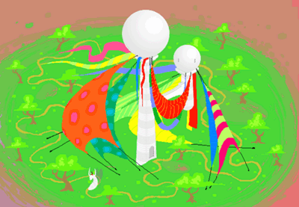

“Its architecture was simplisticly set out in its dual towers. Yet their origins were that of the dream of the world showing time within clouds. The very same Oracles that were the insperation to shape my trees in my leasure of being a treetrimmer.”
Kanaya Maryam
My hive
Harsh burning Desert sun
Home to creatures of the day
Prowling on the innocent
And in this land of chaos
I have found my refuge
My oasis which thrives
Of dream and reality
Most came from ruin
I somehow made my own
Golden towered moons
Fairytale like blue skies
Sculptured trees reminiscent of clouded oracles
We live in night but I thrive in daylight
Chainsaws ring across the green
Well-kept to unfathomable delight
Inspiration accessible to my every design.

The bright green sun pours its rays down upon the desert sand dunes. Its rays seems to trigger the gentle winds creeping in from the east. They rattled each leaf on the oracle shaped trees making a symphony within the cobblestone lined garden. The breeze provoked the brightly patterned sail cloths adorning the white duo orbed towers. Some were tethered to the earth, while others freely fluttered with the kinesthetic energy.
Hive: Noun
- The place of residence for young Trolls called grubs.
- The structure built by droids that is individually designed by young grubs.
- The sanctuary from the wild beasts of the harsh planet of Alternia.
- The oasis to thrive and dream within the vast desert regions which I and my Lusus call my home.
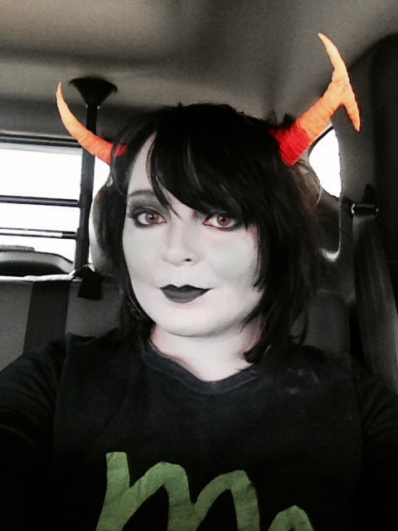
Starlight rains down
open windows
sleepless days
The bluest skies
bookshelves are too full
yet organized
Nocturnal castles
quadrants meant to be filled
lovers star crossed
dying under moons
Secret feelings
never to be told
oh how i wish
this could be reality
only in my dreams
dripping rainbow blood
it was not meant to be
Slowly now i close the book

{Dreaming Rainbow Drinkers}
How to decorate a bedroom like Kanaya Maryam’s
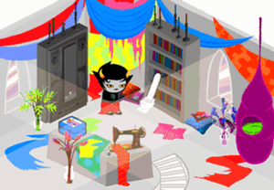
- Clean your room, you cannot have a good craft space with a messy room. Yet alone concentrate.
- Find bright colorful patterned fabric to drape on your walls. Always follow a color scheme
- Find a great workable space for your craft and sewing projects.
- Stock your closet with unique yet fashionable clothing.
- Pack your book shelves (horror, magazines, and vampire novels are great choices.)
- Above all, have fun.
I WATCHED THE CLOUDS DRIFT BY IN FRONT OF THE BRIGHT GREEN SUN. The breeze crept inwards from the windows of my room, like the sand dunes of the desert around my oasis. I was positioned cross legged in my pile of fabric reading a nove on the lore of rainbow drinkers.
[Sidebar Title]
-“Kanaya, what was it like growing up with a lusus instead of a human custodian?”
“I had what was considered a normal Alternian childhood. My lusus raised me to be able to handle the challenges of the harsh desert regions that I lived. Most of my hive was located under grown due to her remarkable burrowing skills.”
-“What were some of the major challenges for you and your Lusus while you were growing up?”
“I believe it was the fact that we both had the understanding of her early death. She knew leaving the caverns would quite literally be the death of her. By the time it came around we were both ready to some extent.”
-“Do you blame Karkat and Sollux for the death of your lusus and the other players in your game session?”
“ Of course not! It was just a silly virus the released, the Mobius Double Reacharound Virus. All of our lusiis deaths were as a result of playing Sgrub. My lusus died from natural causes due inpart to her leaving the caverns to raise me.”
Lusus: Noun
- The custodians or cartakers of young trolls that are based off of a codependency relationship.
- The lifelong bodyguard and visceral type of mentor.
- Lusüs naturae, freaks of nature, within the Latin definition.
- The mother grub who sacrificed her long life to raise me. She protected me from the desert terrors, and was the companion to help me grow.

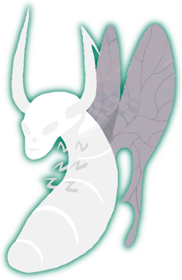
From the stomach of my deceased lusus, and with the assistance of my chain saw, I drew out the Matriourb. It would later become the resurrection of my race as a people. It was the new egg to hatch a new mother grub.
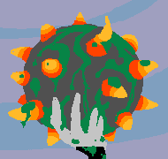
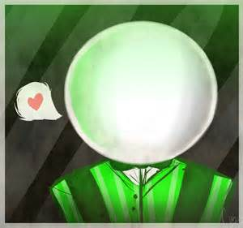
I recall it being white, in every direction. It spanned the entire desert. I could never sleep with so much light. And yet he was there to find the wandering the desert. He was the Father figure to take and guide my hand. He was the one to tuck me into sleep.
The Green Orbed Man
I remember him like yesterday
His green tailed coat, pinstripe
Bowtie and cladded in suspenders
I remember him like yesterday
Posture straight and tall
His language educated as a book
I remember him like yesterday
Guiding me in the desert light
Hand and hand like a father would
I remember him like yesterday
Awakening my mind to see
The golden towers of prospit’s moon
I remember him like yesterday
He been gone until today

“I originally came across him while wondering the sand dunes as a young grub. The light was blinding and cause insomnia He seemed to serve as a father figure to me. I never thought his intentions could be more than maleficent. He later was the one to antagonize Vriska to the point of her killing Aradia by manipulating Sollux.”
{Kanaya Maryam}
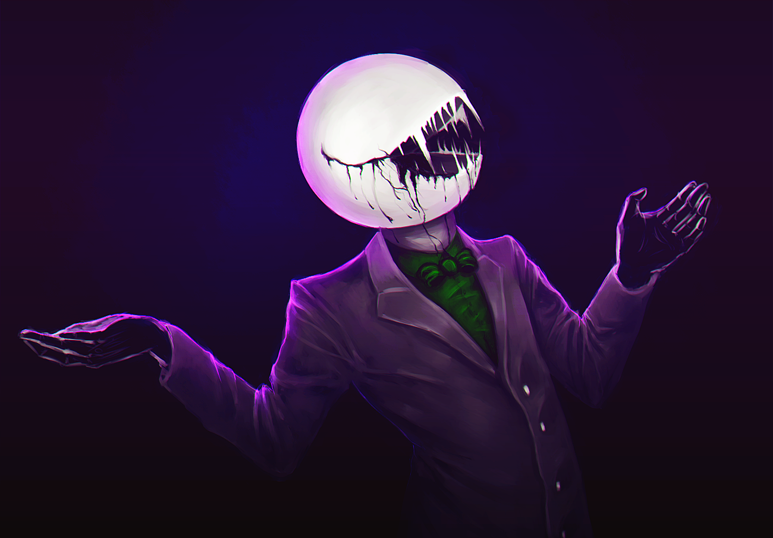
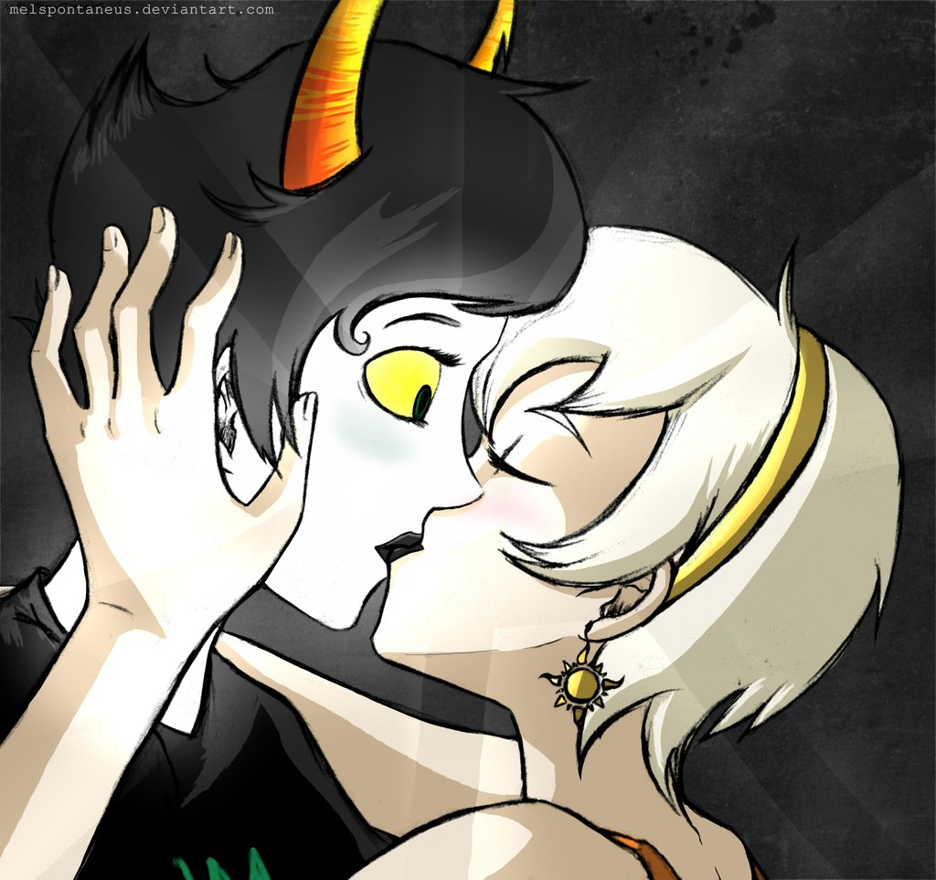
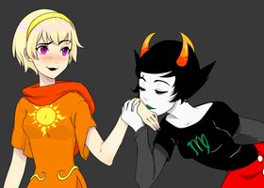
“ I remember I chose to stay behind with Aradia and Sollux to help my friends who had died. Then She came with Dave in the blinding light of the green sun, she was the one to convince me to go with them.”
The First meeting
Matespritship
- The act of holding a Matesprt allegiance with a lover.
- The Alternian definition or equivalent of a soulmate.
- The mutual union of red flush crushes.
- My Rose, though she has thorns to protect her, she is my light.

Kanaya looked down at the small form of her sleeping matesprit. Her soft cheeks were the placement of the shadows of her thick lashes. They were normally died black with what humans refered to as mascara. her light blonde hair form a whisping crown around her head. The rainbow drinker was doing the best she could to help her matesprit with the death of her female custodian. She had been drinking excessivly these past couple of weeks on the metior. It just seemed that kanaya was her cruch, the support to keep her from freying. Though the Alternian felt is was not good enough, it was just enough to keepthe seer of light looking forward. I was enough for her to eventually heal
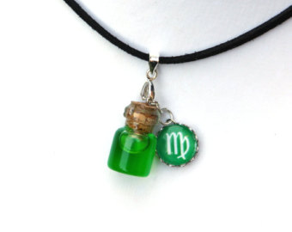
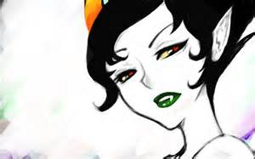

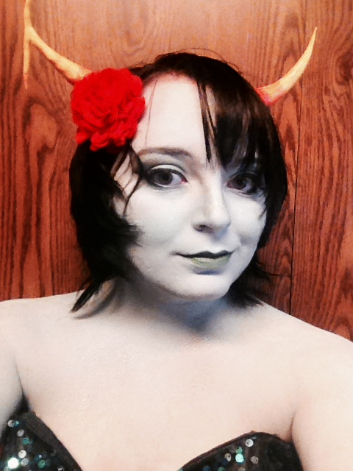
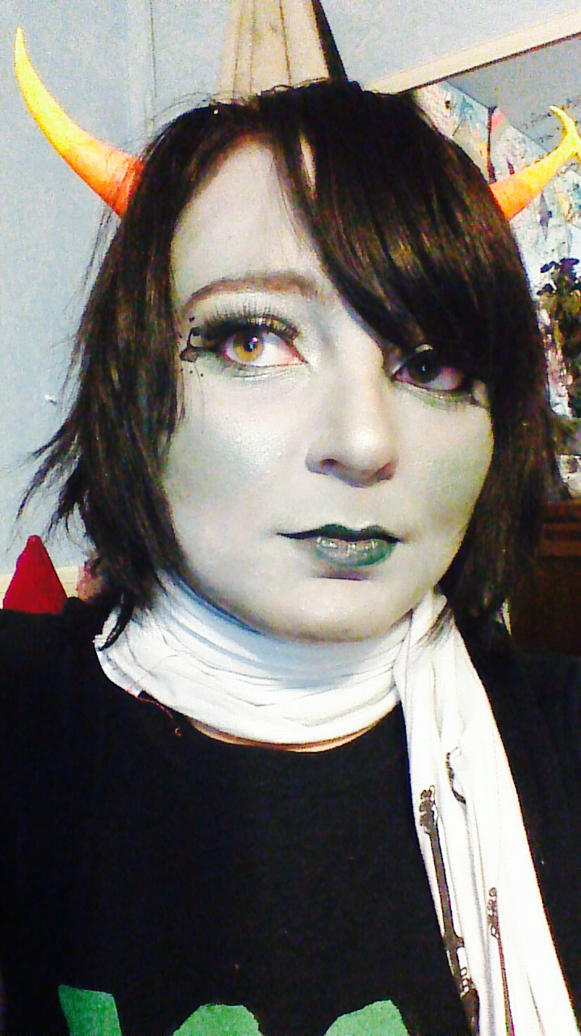
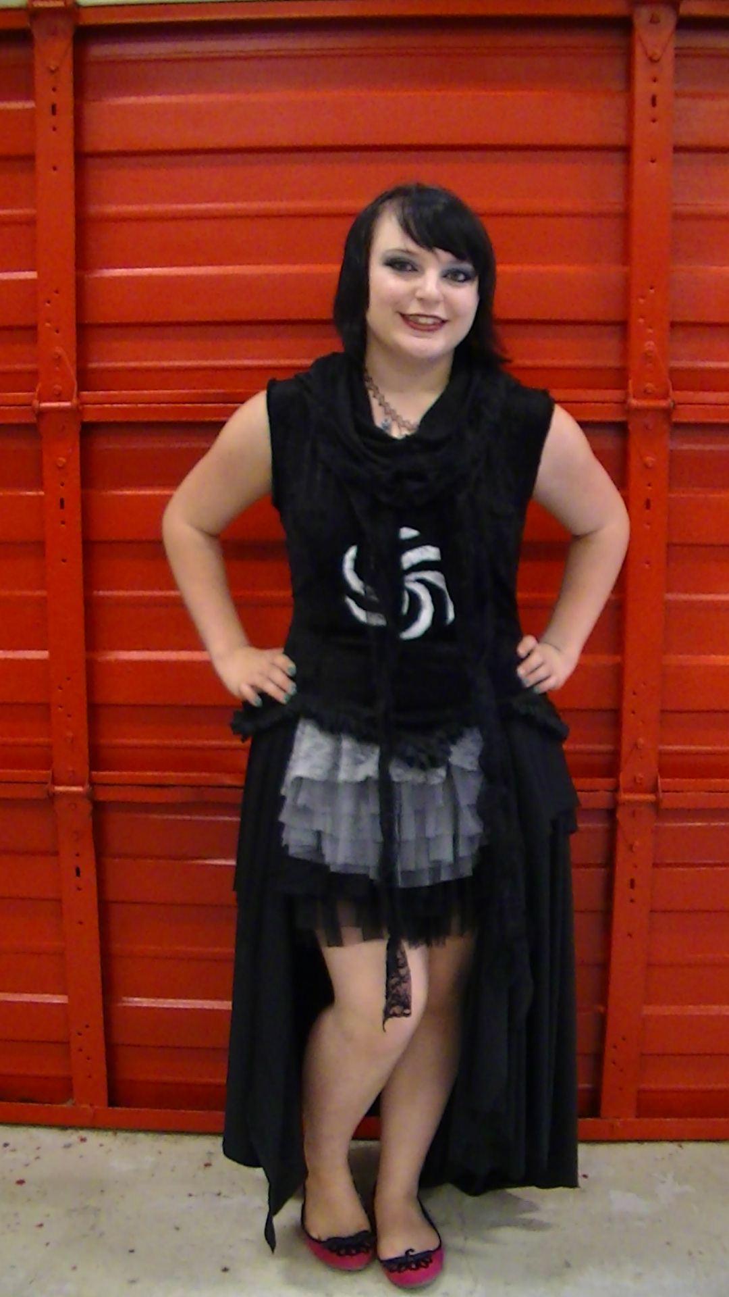
Hide and Seek
I wandered the empty hallways of the meteor, my skin illuminated the hard metal walls. My breath quickened along with my footsteps which echoed down the corridors. I could just faintly hear roses voice ringing like bells, clear and smooth, as she counted down from fifty.
She had introduced a common game that children played for fun. It went by the name of Hide and Seek. She had found it as a recreational game to pass the time. Currently she was down to just twenty number remaining. I had finally found a closet like structure to hide within. The space was surprisingly cramped.
I began to calm down my heart beat. My Descendant Poriam had taught me how to cease the glowing of my skin. It seemed that the genetics of Rainbow Drinkers rand within my lineage, which gave up the signature trait of iridescent skin.
Her silky numbers were drawing ever closer. “5, 4, 3, 2,” the seconds ticked by the slowest they ever had. “1… Kanaya, here I come.” Her voice ecoed down the hallways, taking flight like doves in the blue skies. I could not help but find amusement in her tone of voice. It was the tone that a child would use in play.
I had lost track of the moment in my own amusement I failed to notice her voice and footsteps were drawing closer. It was almost dangerous with her vicinity. “Kanaya, come out, come out.” Her voice was calm and steady. I was hoping that she did not-
“Clap” “Clap”
She was right outside the door. In my shock I could not control my heart-beat. The cabinet slowly lost its shadows with the assistance of my skin.
Her gentle laughter filled the corridor like my illuminist skin. “It is not funny Rose,” I huffed trying to reposition myself. She chuckled while opening the door. “Oh Kanaya, ,my darling Kanaya.” She murmured while bending down to help me out of the predicament of the cabinet.

.
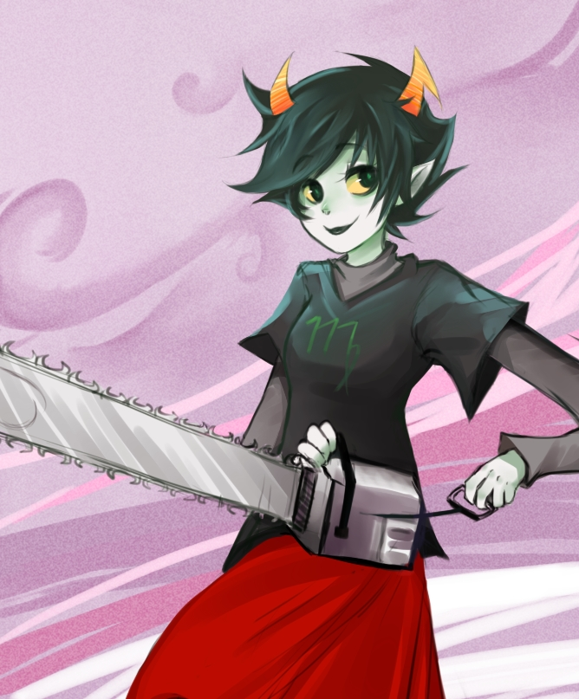

Kanaya’s Playlist
vilify exile: the nationals
Guns For Hands: 21 pilots
No Light, No Light: Florence and the Machine
Little Lion Man: Munford and Sons
Unfinished Business: Mumford and Sons
Dead Hearts: Stars
One step closer: Linkin Park
Awake and Alive: Skillet
My Immortal: Evanescence
Keep holding on: Avril Lavigne
Transatlanticism: Death Cab For Cutie
Watch Over You: Alter Bridge

Rainbow Drinker’s delight
1 cup Lusus cream (White chocolate frozen yogurt)
1 dash Hoovebeast whipped cream (Italian cream frozen yogurt)
2 table spoons Condescendence pearls (strawberry popping Boba)
2 table spoons Summoner treasures (mango popping Boba)
1 table spoon dragon scales (Fruity Pebbles)
2 table spoons Gummy trolls
1 table spoons trickster teeth (coconut shavings)
4 love-struck orbs (cherries)

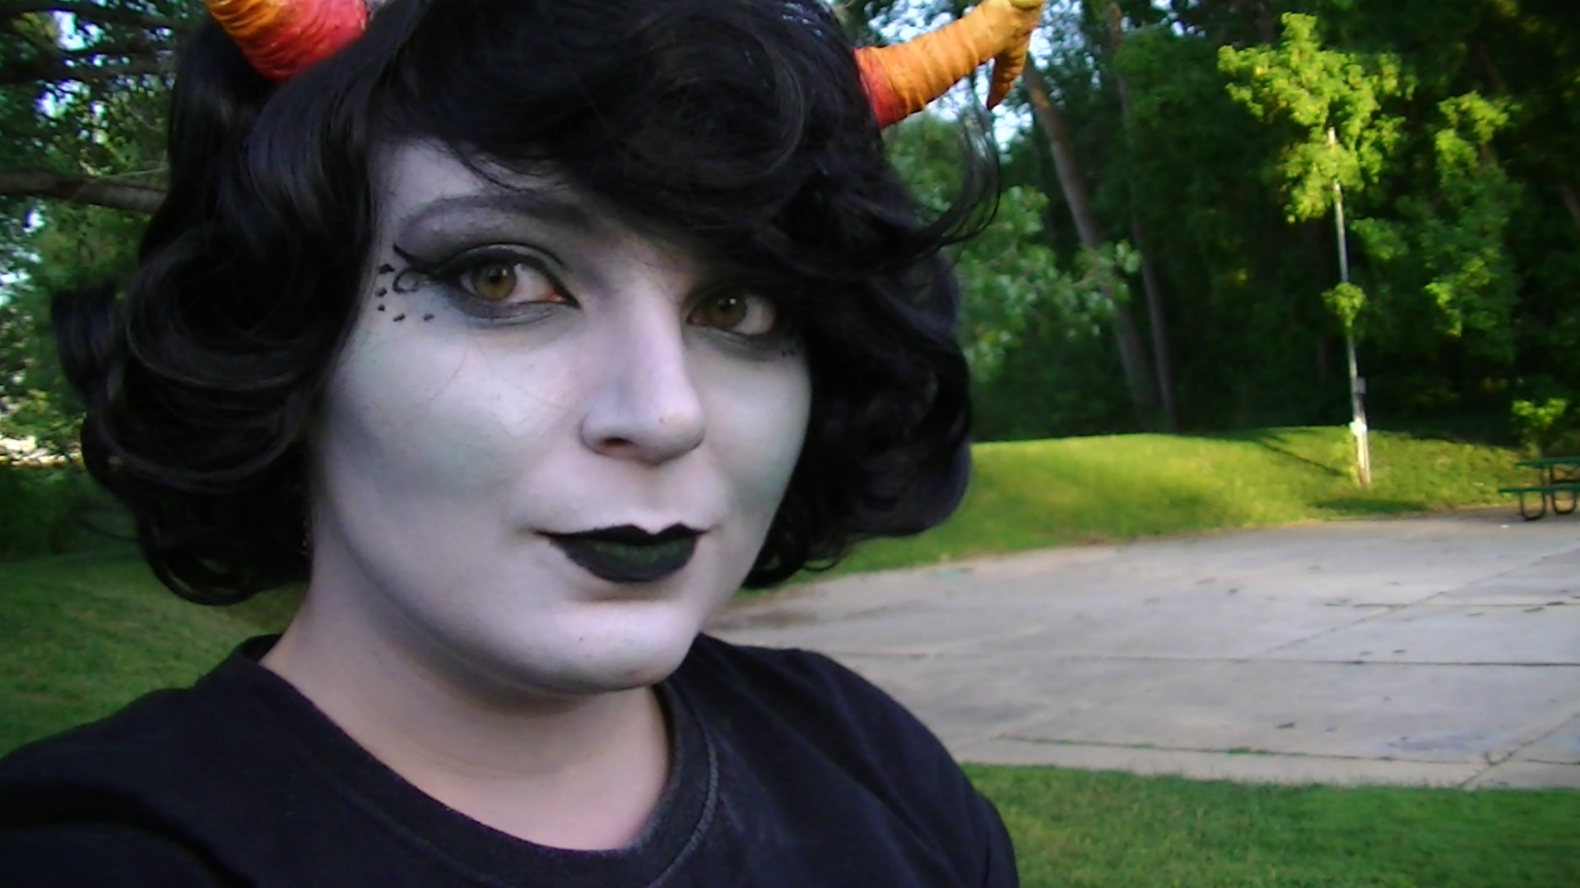

End Notes
Page 2
Hive: Noun
This is a definition that defines what a hive is to Kanaya. She does not take simple meanings from thing, since she is sentimental. It was just not a home but rather a place for her and her Lusus to grow and thrive.
Poetry: My Hive
This poem was meant to describe her hive threw feeling and memories. I wanted it to capture the soul of its purpose.
Vignette: Hivebound
I wanted to provide a snapshot of the actual characteristics of her home. She has an interesting home with its bright colors, and structure.
Quote # 1
I tried to use phrases the she would use to get the reader to understand her though possesses.
Page 3
Exposition, Kanaya’s room
I have always found the look of her bedroom fascinating, I never thought to place fabric on the walls. I have wanted to redo my room so I decided to supply a easy guide of how to decorate a room like hers.
Vignette: The open window
This is a simple snap shot for the reader to have a written aid to see her room.
Poem: literature
I chose to write a poem on the literary works on her book shelves since Alternia has different literature and lore than we do. Trolls have mythical creatures called Rainbow Drinkers, which are equivalent to our vampires, except troll blood comes in different hues.
Page 3
Lusus: Noun
I wanted to define what a lusus was due to fact that trolls are not raised by their parents. I thought it was an important aspect to elaborate on.
Dialog
This dialog was meant to explain what happened to her lusus as well as their relationship.
Vignette
I wanted to show the sacrifices that she had to do for her lusus. But also show the hope of resurrection later on.

